# Calculation of Store Demand Order:

## **For Fresh Veg department:**

**Steps:**

1. Choose the highest sales between Average Sales Last 3 Weeks and Sales Last Week. Suppose it is “sales”.
2. X = sales – input Stock (remaining stock).
3. Y = MBQ – input stock (remaining stock).
4. Z = highest of X and Y.
5. Demanded order = z or nearest multiple of MOQ.

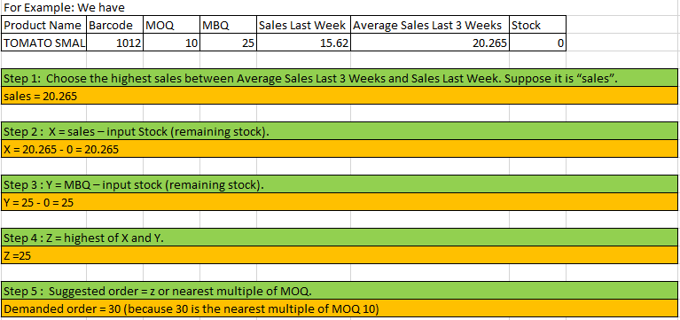

## **For Other Three departments:**

**Steps:**

1. Choose the highest sales between Average Sales Last 3 Weeks and Sales Last Week. Suppose it is “sales”.
2. X = sales + MBQ – Stock from system.
3. Demand order = X or nearest multiple of MOQ.

